**Big Mountain Resort Project Report**

Delving into the data for the Big Mountain Resort along with other resorts in the US revealed a lot of pertinent information for the market. I believe these findings support a decision to increase ticket prices in order to offset increased operational costs. These findings may even be useful in determining the approximate amount by which an increase in price is fair for our business segment.

**Competition** *(What are we competing against?)*

Our cluster analysis revealed three distinct clusters with very distinct stats. Group 1 is the group which I believe fits the business model of a budget resort. These resorts have the shortest vertical drop as well as the shortest summit elevation. With less surface area and equipment to maintain, this group is priced at the lowest price-point of the three groups. It is natural to conclude that this group of resorts may be in the business of providing a comfortable experience for families rather than being a purist skier's ideal destination. This brings us to the second group which is essentially the foil of the first. Group two has the most runs, highest summit and vertical drop as well as runs by a wide margin (on average) all the while open for the most number of days per year too! As a result of these richer amenities for those who came to ski, these resorts are priced at the highest level. Finally, Big Mountain Resort along with others like it fit into a segment right in the middle between the two groups. These resorts are somewhat of a compromise between a seasoned skier’s ideal and a nice vacation for a casual audience, with a midtier price point to go along with ski amenities that fit somewhere in the middle.

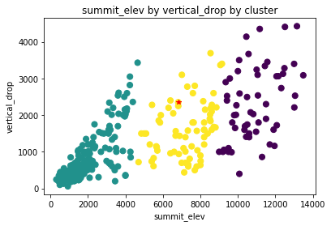

**Our Value Proposition** *(Why are we worth more than we currently charge?)*

The mid-tier option in any business in any industry forces a business to develop a strong niche selling point. For Big Mountain Resort I believe this clear point of distinction is providing a comfortable skiing experience that is exceptional to the customer. This means plenty of resources for skiing even for the night time and less waiting times for lifts. By comparison to our segment group, we have a significantly larger area for night skiing (600 acres) compared to our competition average(67.23 acres). In addition, we have invested more capital into adding ski lifts to improve our skiable area vs total chair lifts ratio to improve customer experience.

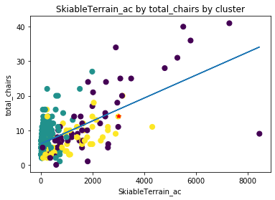

A closer look at our regression model further shows that holding all else equal, adding chair lifts of any size yields a higher weekend adult ticket price. This further shows that better experiences = more value.

**Pricing Gap** *(How much more are we worth?)*

According to the aforementioned model, we are underpriced compared to our competing segment and underpriced against what the model predicted for our resort by around $5 per ticket. While some of that may be within a margin of error or confidence in the model, this model in general does infact lean conservative and under-price resorts as shown below.

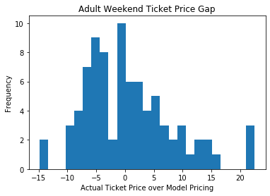

The final reason why we’re actually a bargain is the fact that weekend prices for adults match weekday prices. In my opinion, not pricing weekends higher results in non-trivial lost income just given increased demands alone. Because we are priced higher in the model (that tends to underprice) than our true price and historically *cheap* weekend tickets, **I believe we are more than justified to a $4-5 increase in price for weekend tickets.**